OPPORTUNITY FOR FREE SOLAR THERMAL HEAT/HW SYSTEM!

**Commercial or Community Recipient Sought to Move, Install & Use the
Innovative KSD Stored-Heat Solar System Now in Warwick

WHAT’S THE SOLAR THERMAL PROJECT & WHAT IS BEING PROPOSED/OFFERED?

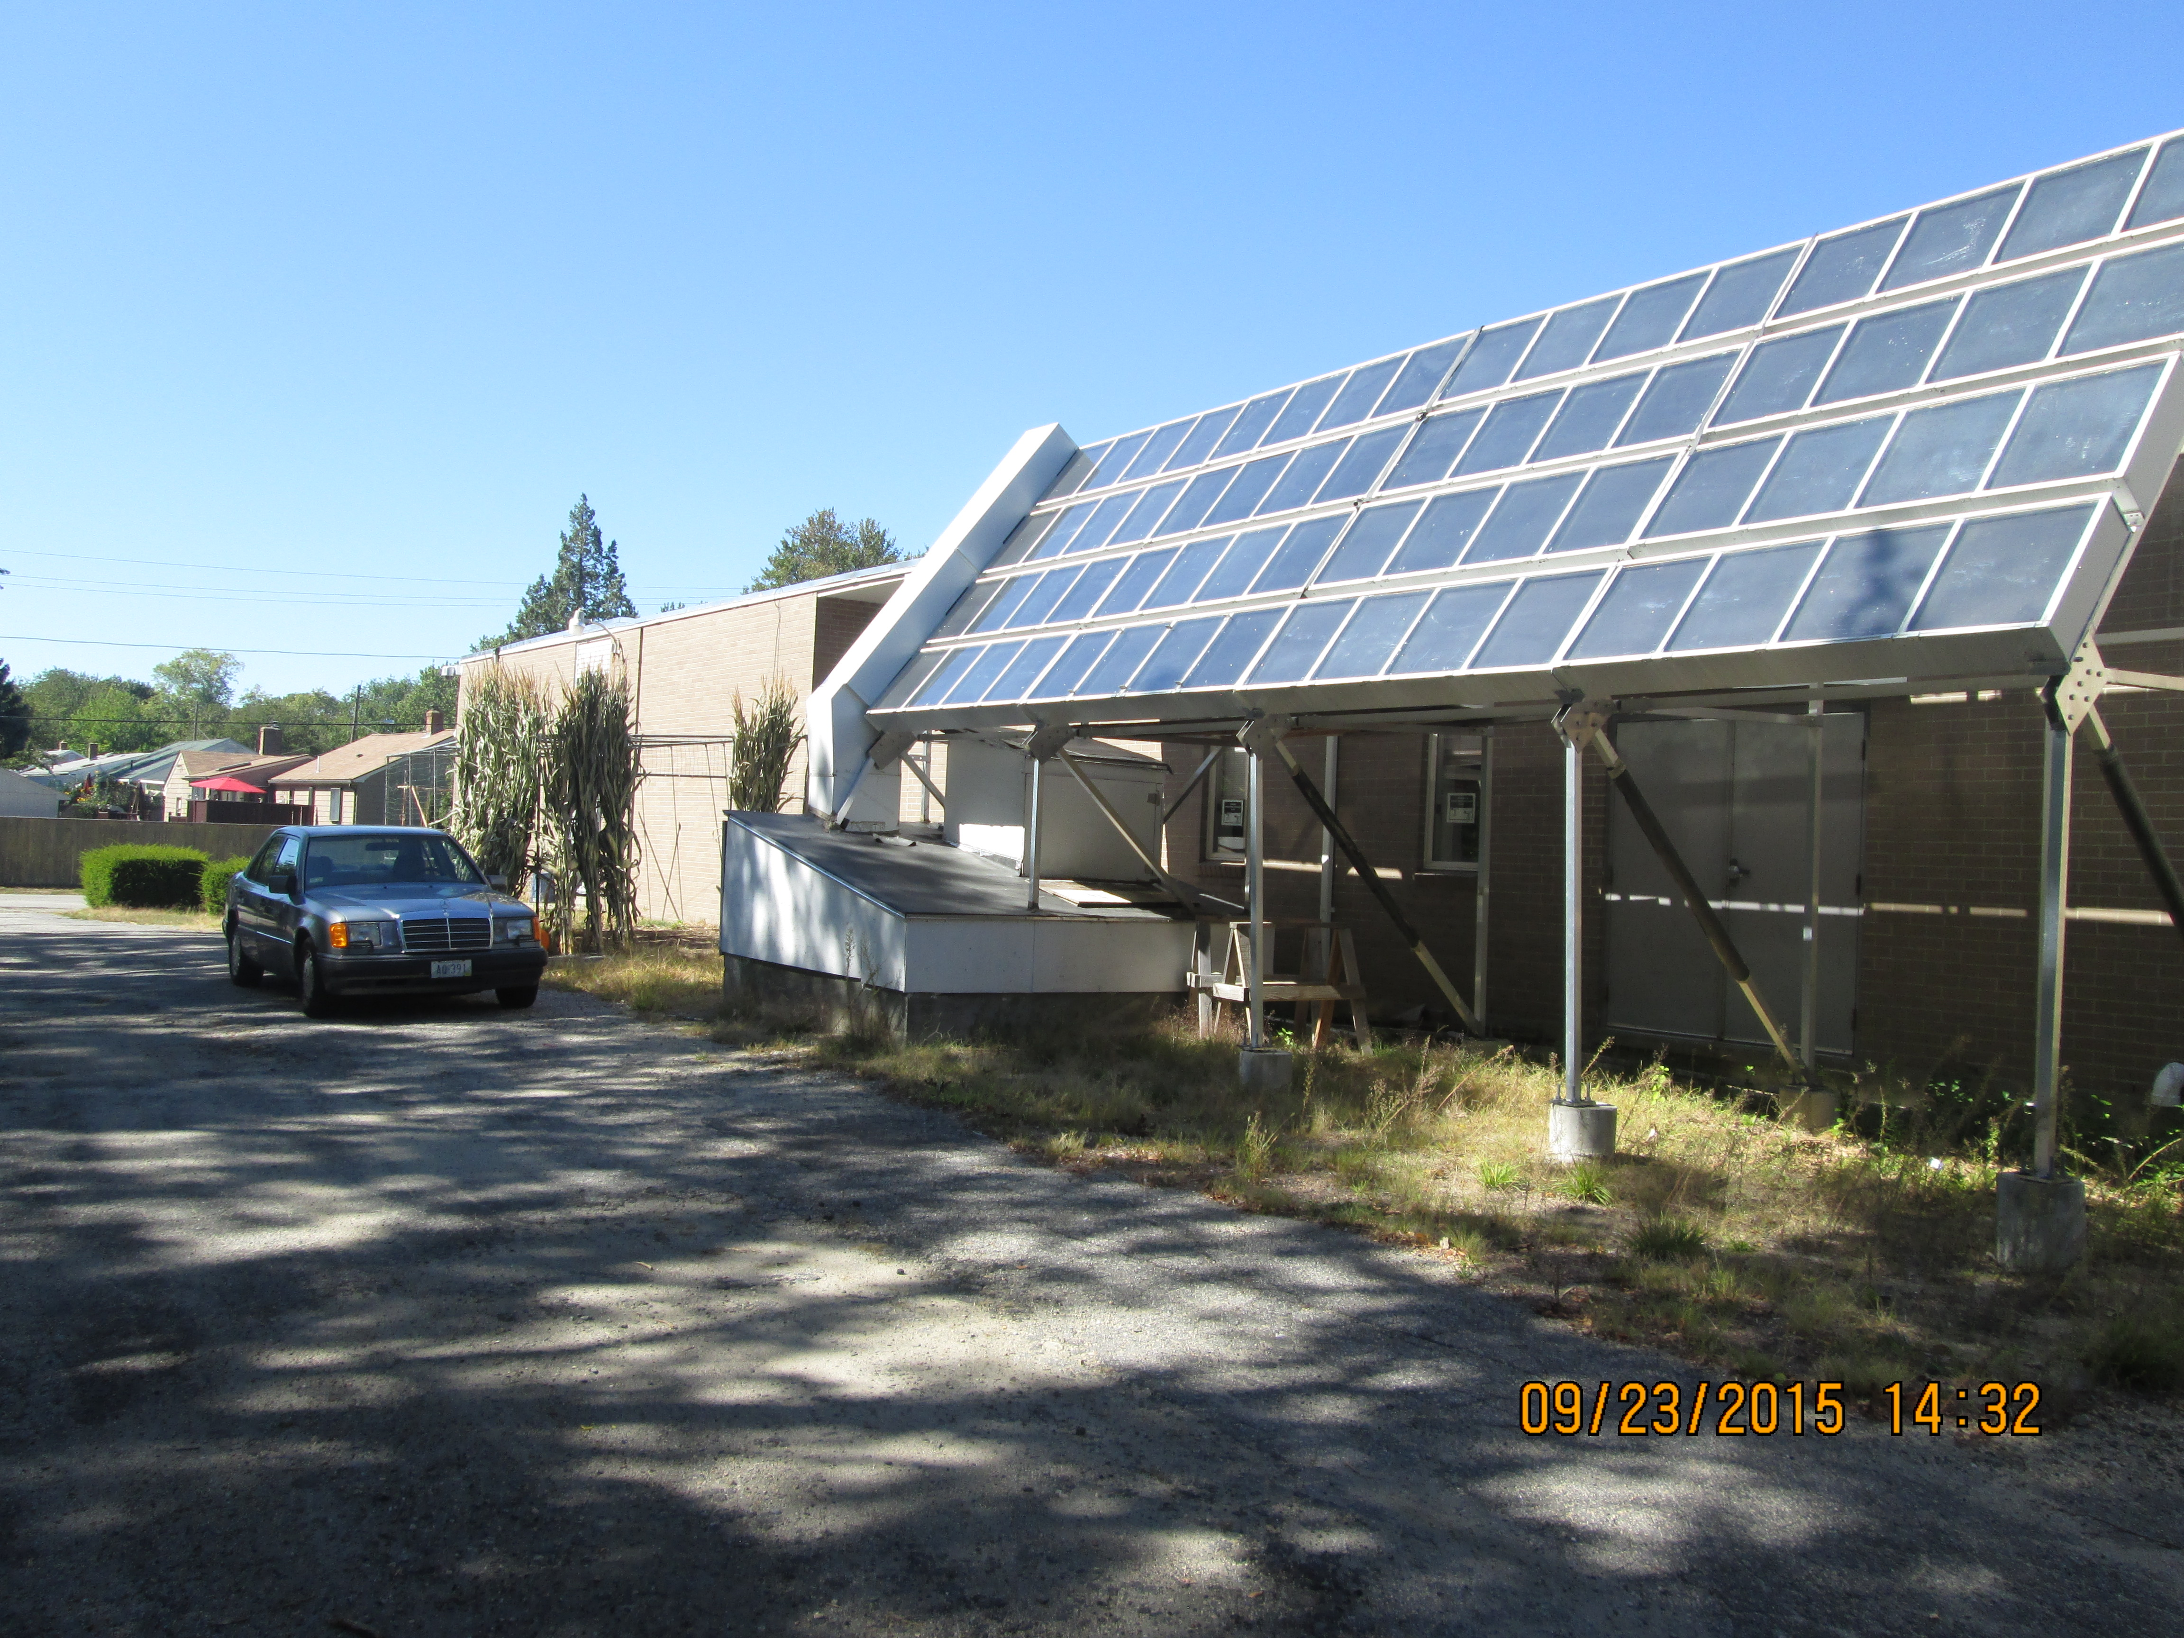

Current Progress: The solar collector and rock box are both built in back of the Hindu Temple in Warwick, however, unlike the previous owner, Temple Am David, there is no longer an extensive use of hot water on the property. (Note: The property was sold just before connecting the system)

What’s Needed? We seek to locate another site on which this completed system may be installed – one with currently expensive energy use, such as an assisted living/senior facility, commercial laundry, restaurant, etc. The recipient only needs to move & install the system to enjoy its benefits.

HOW WILL THIS ADDRESS CLIMATE & ENERGY CONCERNS
& BENEFIT THE NEW OWNER?

We will be combining the solar collector, rock bed/heat storage unit and possibly a heat pump to provide hot water or heat to a community or commercial building without the need for fossil fuels. This would result in a great reduction in energy expense at the new site.

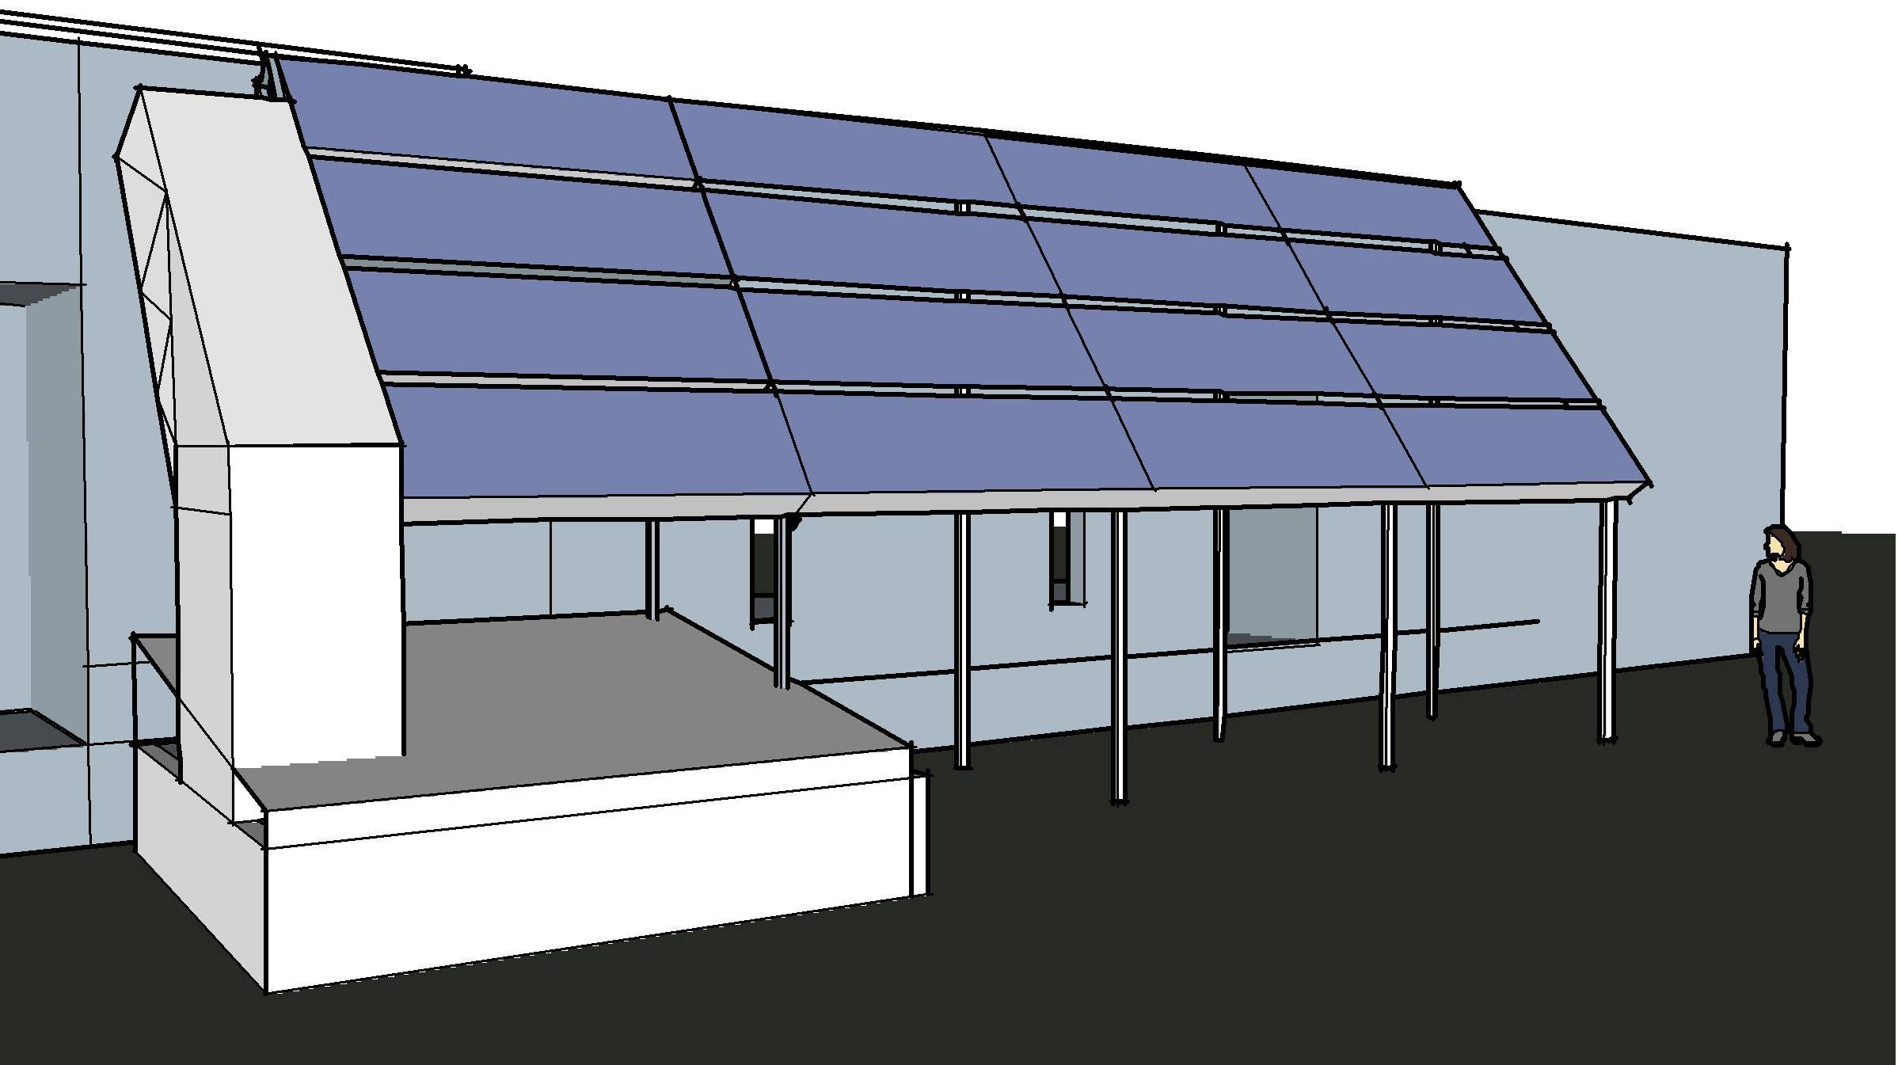
PROBLEM SOLVED - & THE NEW FEATURE CAN MAKE THINGS EVEN BETTER!
A solar collector and rock bed alone historically could breed mold in summer months. Our collector and rock bed in conjunction with a hydronic hot water circulating system solves the mold problem. Another option: our solar collector & rock bed combined with the new heat pump technology is overwhelmingly superior to a hydronic system, and is capable of supplying 90% of winter heat and/or 50% of hot water, displacing large amounts of fossil fuels & cost..

***********************************************************************************************
FOR MORE INFORMATION OR TO OFFER ASSISTANCE
IN FINDING A NEW HOME FOR THE SYSTEM, CONTACT

KLINKMAN SOLAR DESIGN (KSD)
Paul Klinkman & Liberty Goodwin, Co-Owners
    - info@klinkmansolar.com
Web: www.klinkmansolar.com
**********************************************************************************************

